13 Colonies Tourist Project

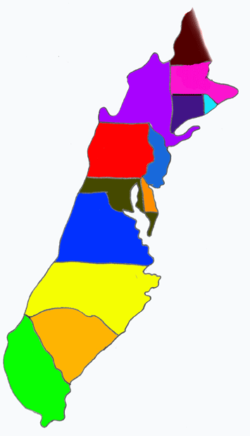

Directions: It is September 3, 1735. Congratulations! You have been chosen as the chief councilperson of one of the 13 original colonies tourist boards. Your job, as the board leader, is to increase people’s desire to vacation in your particular colony. To help you promote your colony to the many Americans throughout the land, you will need to create a short presentation (3-5 minutes) to increase interest.

In your presentation you must include:
- Visual aid (PowerPoint, PowToon, Glogster, Prezi, poster, brochure, etc.)
- Creative Slogan
- Reasons to visit your colony
- Important travel information (climate, weather, geography, crime rate, etc.)

Information for your presentation must include, but is not limited to:
- Map of your colony
- Reason your colony was founded
- Climate/weather
- Geography
- Culture of the area
- Major events of the past/present
- Things to do for fun

We will be in the media center on _______________________________________________.

Remember, everything you report on in your presentation MUST be ACCURATE for 1735, not modern day!

Due Date: ______________________________________________

This project will be worth a total of 100 point.

CATEGORY | 100-80 | 79-60 | 59-30 | 29-0
Amount of Information | All topics are addressed and all questions answered in the required length | All topics are addressed and most questions answered with at least 2 sentences about each. | All topics are addressed, and most questions answered with 1 sentence about each. | One or more topics were not addressed.
Quality of Information | Information clearly relates to the main topic. It includes several supporting details and/or examples. | Information clearly relates to the main topic. It provides 1-2 supporting details and/or examples. | Information clearly relates to the main topic. No details and/or examples are given. | Information has little or nothing to do with the main topic.
Organization | Information is very organized with well-constructed paragraphs and subheadings. | Information is organized with well-constructed paragraphs. | Information is organized, but paragraphs are not well-constructed. | The information appears to be disorganized.
Content - Accuracy | At least 7 accurate facts are displayed on the project. | 5-6 accurate facts are displayed on the project. | 3-4 accurate facts are displayed on the project. | Less than 3 accurate facts are displayed on the project.
Grammar | There are no grammatical mistakes on the project. | There is 1 grammatical mistake on the project. | There are 2 grammatical mistakes on the project. | There are more than 2 grammatical mistakes on the project.
Attractiveness | The project is exceptionally attractive in terms of design, layout, and neatness. | The project is attractive in terms of design, layout and neatness. | The project is acceptably attractive though it may be a bit messy. | The project is distractingly messy or very poorly designed. It is not attractive.

