American History I
Unit 4: Nationalism, Sectionalism, and Expansion
***********************************************************************************
Assignment Due Dates:

- Vocabulary 4a: 11/4/15
- Primary Source 1: 11/7/16
- Vocabulary 4b: 11/10/16
- Primary Source 2: 11/14/16
- Binder Check (Units 1-4): 11/16/17
- Discussion Questions: 11/18/16
- Current Event: 11/18/16
- Essay: 11/18/16
Quiz Date: 11/4/16
Test Date: 11/18/16
**************************************************************************************
STUDENT OBJECTIVES:
- Students will be able to explain who rhetoric and text structure can advance ideas.
- Students will be able to analyze the tensions between freedom, equality, and power.
- Students will be able to understand how reform movements influenced each other.
- Students will be able to compare and contrast the causes and effects of migration and expansionism.
- Students will be able to analyze the effectiveness of Manifest Destiny and its impact on American development.
- Students will be able to identify the role of the frontier in American history.

VOCABULARY TO KNOW:
Unit 4a: Reform Movements

- Abolitionism
- Charles G. Finney
- Dorothea Dix
- Elizabeth Cady Stanton
- Evangelical
- Frederick Douglass
- Gag Rule
- Henry David Thoreau
- Horace Mann
- Joseph Smith
- Lucreita Mott
- Mormon
- Nat Turner
- Neal Dow
- Ralph Waldo Emerson
- Revivalist
- Second Great Awakening
- Seneca Falls Declaration
- Sojourner Truth
- Susan B. Anthony
- Temperance Movement
- transcendentalist
- Unitarian
- Utopian Community
- William Lloyd Garrison

Unit 4b: Westward Expansionism

- Alamo
- Brigham Young
- California Gold Rush
- Forty-niners
- Gadsden Purchase
- James K. Polk
- Junípero Serra
- Lone Star Republic
- Manifest Destiny
- Mexican-American War
- Mountain Men
- Oregon Trail
- Sam Houston
- Santa Anna
- Santa Fe Trail
- Stephen Austin
- Treaty of Fort Laramie
- Treaty of Guadalupe Hidalgo
- Wilmot Proviso
- Zachary Taylor

DISCUSSION QUESTIONS:
- What was the goal of the Second Great Awakening?
- How did Christian revivalism affect American politics and society?
- Why did many Americans discriminate against the Mormons?
- Were utopian communities truly utopian? Explain.
- What did the public school movement accomplish?
- What motivated Dorothea Dix to campaign for reform?
- Was the temperance movement successful? Why or why not.
- How did enslaved people resist their captivity?
- Were freedmen free from discrimination? Explain.
- Explain the role religion played in the abolitionist movement.
- Why might women’s rights have been so limited in the early years of this nation?
- Why did some abolitionists become outspoken advocates for women’s rights?
- Explain the significance of the Seneca Falls Convention.
- What role did mountain men play in westward expansion?
- Who might have agreed with the idea of Manifest Destiny? Why might have disagreed?
- If you were a poor farmer in the 1850s, would you have chosen to join a wagon train to the West? Why or why not.
- In what ways was the fighting in Texas the responsibility of both the Anglo-Texans and the Mexicans?
- Do you think Polk was justified in asking Congress to declare war on Mexico? Explain.
- Was the compromise over Oregon fair? Explain.
- How did the Treaty of Guadalupe Hidalgo settle the chief conflicts that led to the Mexican-American War?
- What do you think was the most important long-term result of the Mexican-American War?
- Who benefitted most from the California Gold Rush?

ESSAY TOPIC (THEMATIC):
How did the idea of Manifest Destiny change the American landscape by the 1860s?

ESSAY GUIDELINES:
- The essay needs to follow the guidelines for an analytical, five-paragraph essay.
- It should have at least five paragraphs, an argumentative thesis statement, specific historical examples, and at least one quotation.
- The length requirement is 2-3 pages, double-spaced, typed, 1-inch margins, 12 point font.
- Use Chicago Manual Style (footnotes or endnotes) for any citations.
- Documents must be referenced within the essay as follows:
Example: The concept Manifest Destiny affected many Americans in the 19th century (document 4).
- Don’t forget to check your spelling and grammar before submitting your final copy. I recommend having another student peer-edit your essay or bringing it into me early to check it over.
- A note on plagiarism: Copying and pasting—either parts or whole essay—from the internet is cheating. If you are discovered to have done this, you will receive a zero on this assignment and a written referral to the office.
CURRENT EVENT REQUIREMENT:
- You must find an article from either a print newspaper or a news website that focuses on one of the following issues:

  - Native American affairs
  - Expansionism
  - Migration
  - War
  - Treaties
  - Frontier/wilderness
  - Reform
  - Education
  - Prison system
  - Religion

- After you find an article on an approved topic, you need to either print out the article or cut it out of the newspaper.
- Read over the entire article and then complete a current events worksheet on what you read.

*********************************************************************************************

At the end of this unit, you will BE ABLE TO:

4.1 Analyze the political issues and conflicts that impacted the United States through Reconstruction and the compromises that resulted.
4.4 Analyze the cultural conflicts that impacted the United States through Reconstruction and the compromises that resulted.
5.2 Explain how judicial, legislative, and executive actions have affected the distribution of power between levels of government.
2.1 Analyze key political, economic, and social turning points from colonization through Reconstruction in terms of causes and effects (e.g., conflicts, legislation, elections, innovations, leadership, movements, Supreme Court decisions, etc.).
2.2 Evaluate key turning points from colonization through Reconstruction in terms of their lasting impact (e.g., conflicts, legislation, elections, innovations, leadership, movements, Supreme Court decisions, etc.).

DBQ Essay – Part A

Directions: Analyze the following documents and answer the guided questions following each document. Using what you learn from the documents and your own background knowledge of the subject, answer the essay question.

Document 1: John L. O’Sullivan on Manifest Destiny, 1839
The American people having derived their origin from many other nations, and the Declaration of National Independence being entirely based on the great principle of human equality, these facts demonstrate at once our disconnected position as regards any other nation; that we have, in reality, but little connection with the past history of any of them, and still less with all antiquity, its glories, or its crimes. On the contrary, or national birth was the beginning of a new history, the formation and progress of an untried political system, which separates us from the past and connects us with the future only; and so far as regard the entire development of the natural rights of man, in moral, political, and national life, we may confidently assume that our country is destined to be the great nation of futurity.

- What is John O’Sullivan’s view on our connection with the past and future?

- What does he think our country is destined to be?
Document 2: American Progress, John Gast, 1872

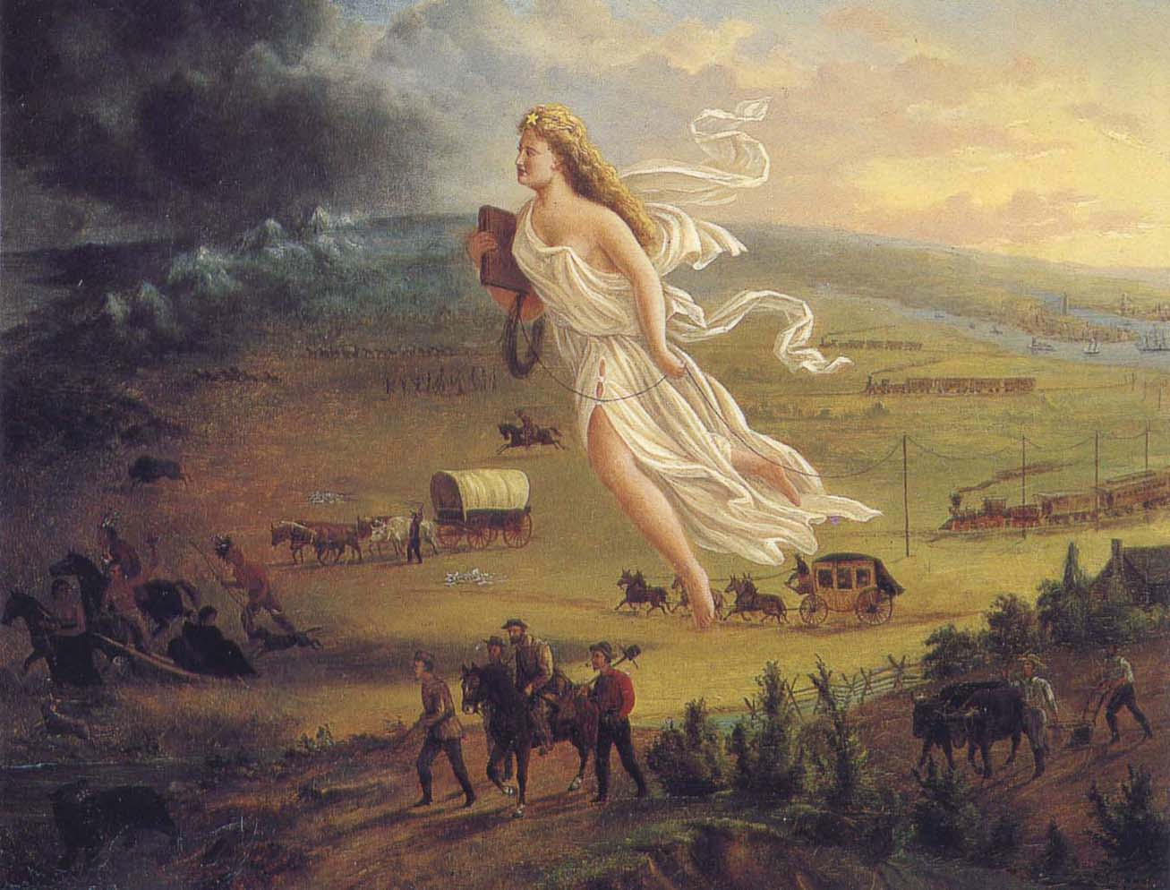

- What appears to be the direction of movement in this image?

- Contrast the image from right to left. Who does the lady in white represent?

Document 3: Congress resolution to annex Texas, 1845
Resolved by the Senate and House of Representatives of the United States in Congress assembled, That Congress doth consent the territory properly included within, and rightfully belonging to the Republic of Texas, may be erected into a new State, to be called the State of Texas, with a republican form of government, to be adopted by the people of said republic, by deputies in convention assembled, with the consent of the existing government, in order that the same may be admitted as one of the States of the Union.

And be it further resolved, That the foregoing consent of Congress is given upon the following conditions, and with the following guarantees to wit:

First said state to be formed, subject to the adjustment by this government of all questions of boundary that may arise with other governments: and the constitution thereof, with the proper evidence of its adoption by the people of said Republic of Texas, shall be transmitted to the President of the United States, to be laid before Congress for its final action, on or before the first day of January, on thousand eight hundred and forty-six.

- To what country is Texas being annexed?

- Who has the power to “adjust boundaries questioned by other countries?

- Which countries might question the boundaries of Texas?

Document 4: Map of Disputed Texas Border

- What natural geographic boundary marks the boundary of undisputed Texas?

- What natural geographic boundary marks the disputed territory?

Document 5: Declaration of War on Mexico by President James K. Polk, 1846

- Who does President Polk call upon to preserve order?

- According to Polk, who has blessed the abridging of its calamities?

- Who does Polk blame for his declaration of war?

Document 6: Article V of the Treaty of Guadelupe Hidalgo
The boundary line between the two Republics shall commence in the Gulf of Mexico, three leagues from land, opposite the mouth of the Rio Grande, otherwise called Rio Bravo del Norte, or opposite the mouth of its deepest branch, if it should have more that one branch emptying directly into the sea; from thence up the middle of that river, following the deepest channel, where it has more than one, to the point where it strikes the southern boundary of New Mexico; thence, westwardly, along the whole southern boundary of New Mexico (which runs north of the town called Paso)to its western termination; thence northward, along the western line of New Mexico, until it intersects the first branch of the river Gila; (or if it should not intersect any branch of that river, then to the point on the said line nearest to such branch, and thence in a direct line to the same); thence down the middle of the said branch and of the said river, until it empties into the Rio Colorado; thence across the Rio Colorado, following the division line between upper and Lower California, to the Pacific Ocean.

The southern and Western limits of New Mexico, mentioned in the article, are those laid down in the map entitled “Map of the United Mexican States, as organized and defined by various acts of the Congress of said republic, and constructed according to the best authorities. Revised edition. Published at New York, in 1847, by J. Disternell, “ of which map a copy is added to this treaty, bearing the signatures and seals of the undersigned Plenipotentiaries,. And, in order to preclude all difficulty in tracing upon the ground the limit separating Upper from Lower California, it is agreed that the said limit shall consist of a straight line drawn from the middle of the Rio Gila, where it unites with the Colorado. To a point on the coast of the Pacific Ocean, distant tone marine league due south of the southernmost Point of the port of San Diego, according to the plan of said port made in the year 1782 by Don Juan Pantoja, second sailing master of the Spanish fleet, and published at Madrid in the year 1802, in the atlas to the voyage of the schooners Sutil and Mexicana; of which plan a copy is hereunto added, signed and sealed by the respective Plenipotentiaries

- What does this portion of the treaty ending the War of with Mexico seem to be setting up?

- Why do you suppose the authors included such detail about the source maps and attached them to the document?

Document 7: Map, Lands of the Mexican Cession
- What familiar states are included in this new territory?

- Why do you think the US did not try to add more territory under the premise of Manifest Destiny?

Document 8: Map, the US by 1860

- What limits US growth to the North, South, East, and West?

- Why do you think the idea of Manifest Destiny was limited by these boundaries?

