American History I
Unit 5: Civil Crisis and Civil War
***********************************************************************************
Assignment Due Dates:

- Vocabulary 5a: 11/24/15
- Primary Source 1: 11/30/15
- Vocabulary 5b: 12/8/15
- Primary Source 2: 12/9/15
- Discussion Questions: 12/16/15
- Current Event: 12/16/15
- Essay: 12/18/15
Quiz Date: 12/4/15
Test Date: 12/18/15
**************************************************************************************
STUDENT OBJECTIVES:
- Students will be able to explain who rhetoric and text structure can advance ideas.
- Students will be able to analyze the tensions between freedom, equality, and power.
- Students will be able to understand how tensions between freedom, equality, and power have shaped the political, economic, and social development of the United States.
- Students will be able to explain the impact of wars on American politics and society through Reconstruction.

VOCABULARY TO KNOW:
Unit 5a: Causes of the Civil War

- “Bleeding Kansas”
- Compromise of 1850
- Crittenden Compromise
- Dred Scott Decision
- Free-soil Party
- Fugitive Slave Act
- Harper’s Ferry Raid
- Harriet Beecher Stowe
- Harriet Tubman
- John Brown
- Kansas-Nebraska Act
- Lincoln-Douglas Debates
- Popular Sovereignty
- Secession
- Underground Railroad

Unit 5b: Civil War

- 1st Battle of Bull Run
- 54th Massachusetts Regiment
- Anaconda Plan
- Antietam
- Appomattox Courthouse
- Border State
- Chancellorsville
- Confederate States of America
- Emancipation Proclamation
- Fort Sumter
- George B. McClellan
- George Pickett
- Gettysburg Address
- Jefferson Davis
- P.G.T. Beauregard
- Robert E. Lee
- Thomas “Stonewall” Jackson
- Ulysses S. Grant
- Vicksburg
- William T. Sherman

DISCUSSION QUESTIONS:
- How did northerners and southerners view slavery?
- What role did the Free-Soil Party play in the election of 1848?
- How did California statehood spark a new crisis over slavery?
- What were the provisions of the Compromise of 1850?
- In what ways did the Fugitive Slave Act affect free blacks?
- Why were so many people upset over the Kansas-Nebraska Act of 1854?
- Why did violence ultimately break out in Kansas following the Kansas-Nebraska Act?
- How did the rise and fall of political parties reflect divisions in the United States?
- Describe the circumstances of the Dred Scott case.
- How successful was John Brown’s raid on the arsenal at Harper’s Ferry?
- What reasons did the Deep South give for their secession from the Union?
- Why were shots fired at Fort Sumter?
- What were some of the strengths and weaknesses of the Union? The Confederacy?
- Describe the strategy of the Union. The Confederacy.
- How did the Union blockade affect the Confederate economy?
- Why did Lincoln decide to change his stance on slavery midway through the war?
- Who was officially freed by the Emancipation Proclamation? Explain the legal issues with the Proclamation.
- What was the northern response to conscription?
- How did women contribute to the war effort?
- Explain the significance of the Gettysburg Address.

ESSAY TOPIC (THEMATIC):
Compare the North and South in 1860 and then again in 1864. Why did the Union Army ultimately win the American Civil War?

ESSAY GUIDELINES:
- The essay needs to follow the guidelines for an analytical, five-paragraph essay.
- It should have at least five paragraphs, an argumentative thesis statement, specific historical examples, and at least one quotation.
- The length requirement is 2-3 pages, double-spaced, typed, 1-inch margins, 12 point font.
- Use Chicago Manual Style (footnotes or endnotes) for any citations.
- Documents must be referenced within the essay as follows:
Example: The concept Manifest Destiny affected many Americans in the 19th century (document 4).
- Don’t forget to check your spelling and grammar before submitting your final copy. I recommend having another student peer-edit your essay or bringing it into me early to check it over.
- A note on plagiarism: Copying and pasting—either parts or whole essay—from the internet is cheating. If you are discovered to have done this, you will receive a zero on this assignment and a written referral to the office.

CURRENT EVENT REQUIREMENT:
- You must find an article from either a print newspaper or a news website that focuses on one of the following issues:

  - Native American affairs
  - Expansionism
  - Migration
  - War
  - Treaties
  - Frontier/wilderness
  - Reform
  - Education
  - Prison system
  - Religion

- After you find an article on an approved topic, you need to either print out the article or cut it out of the newspaper.
- Read over the entire article and then complete a current events worksheet on what you read.

*********************************************************************************************

At the end of this unit, you will BE ABLE TO:

4.1 Analyze the political issues and conflicts that impacted the United States through Reconstruction and the compromises that resulted.
4.4 Analyze the cultural conflicts that impacted the United States through Reconstruction and the compromises that resulted.
5.2 Explain how judicial, legislative, and executive actions have affected the distribution of power between levels of government.
2.1 Analyze key political, economic, and social turning points from colonization through Reconstruction in terms of causes and effects (e.g., conflicts, legislation, elections, innovations, leadership, movements, Supreme Court decisions, etc.).
2.2 Evaluate key turning points from colonization through Reconstruction in terms of their lasting impact (e.g., conflicts, legislation, elections, innovations, leadership, movements, Supreme Court decisions, etc.).

DBQ Essay

Directions: Analyze the following documents and answer the guided questions following each document. Using what you learn from the documents and your own background knowledge of the subject, answer the essay question.

Document 1: John L. O’Sullivan on Manifest Destiny, 1839
The American people having derived their origin from many other nations, and the Declaration of National Independence being entirely based on the great principle of human equality, these facts demonstrate at once our disconnected position as regards any other nation; that we have, in reality, but little connection with the past history of any of them, and still less with all antiquity, its glories, or its crimes. On the contrary, or national birth was the beginning of a new history, the formation and progress of an untried political system, which separates us from the past and connects us with the future only; and so far as regard the entire development of the natural rights of man, in moral, political, and national life, we may confidently assume that our country is destined to be the great nation of futurity.

- What is John O’Sullivan’s view on our connection with the past and future?

- What does he think our country is destined to be?

Document 2: American Progress, John Gast, 1872

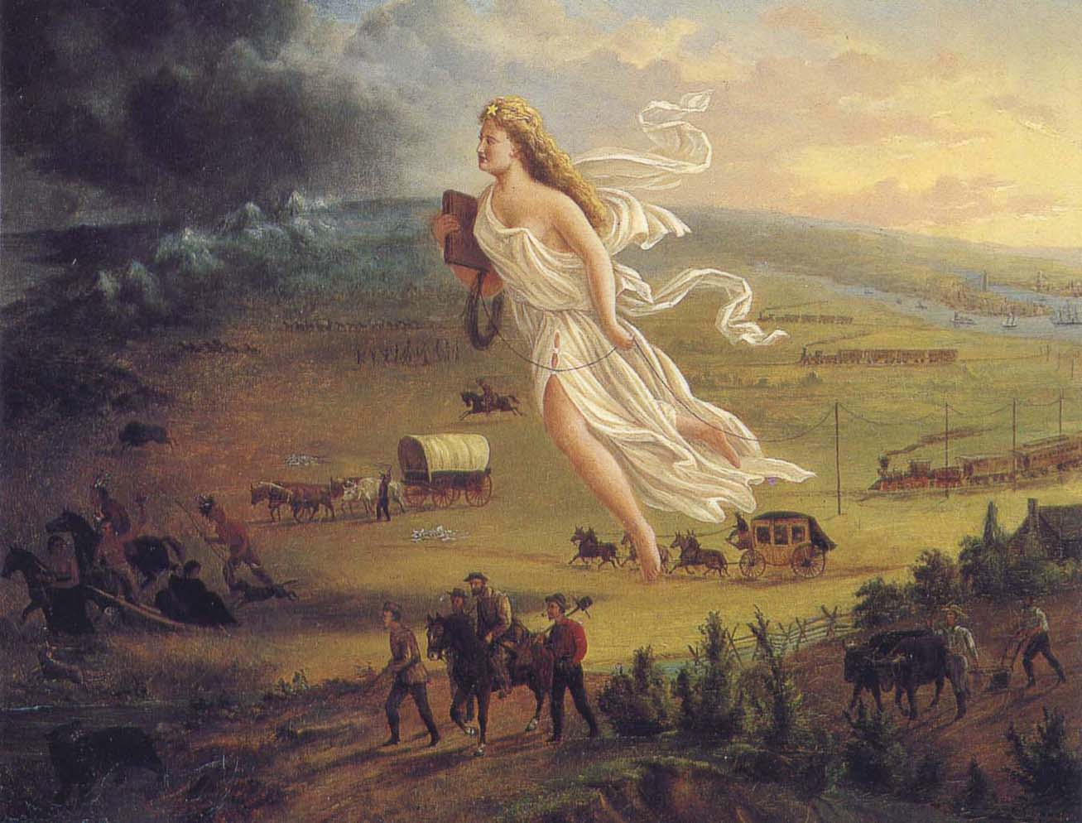

- What appears to be the direction of movement in this image?

- Contrast the image from right to left. Who does the lady in white represent?

Document 3: Congress resolution to annex Texas, 1845
Resolved by the Senate and House of Representatives of the United States in Congress assembled, That Congress doth consent the territory properly included within, and rightfully belonging to the Republic of Texas, may be erected into a new State, to be called the State of Texas, with a republican form of government, to be adopted by the people of said republic, by deputies in convention assembled, with the consent of the existing government, in order that the same may be admitted as one of the States of the Union.

And be it further resolved, That the foregoing consent of Congress is given upon the following conditions, and with the following guarantees to wit:

First said state to be formed, subject to the adjustment by this government of all questions of boundary that may arise with other governments: and the constitution thereof, with the proper evidence of its adoption by the people of said Republic of Texas, shall be transmitted to the President of the United States, to be laid before Congress for its final action, on or before the first day of January, on thousand eight hundred and forty-six.

