ELECTIONS OF 1824 AND 1828

Election of 1824
- Candidates: A field of seventeen candidates was soon narrowed to four serious contenders. All were members of the Democratic-Republican Party. The Federalist Party had disappeared during the Era of Good Feeling. Although the candidates belonged to the same political party, each represented the special interests of their section of the country.

John Quincy Adams, from the North (Massachusetts), was the son of former President John Adams. At the time of the election, he was President James Monroe’s Secretary of State.

William H. Crawford, from the South (Georgia), was Monroe’s Secretary of the Treasury. The President hoped that Crawford would succeed him.

Henry Clay, from the West (Kentucky), was a popular leader in the House of Representatives.

Andrew Jackson, from the West (Tennessee), was the hero of the Battle of New Orleans in the War of 1812. He was a United States senator in 1824.

- The Campaign: Crawford had been chosen to be a presidential candidate at a meeting attended by only one-third of the Democratic-Republicans in Congress. Other party members called his nomination undemocratic, and against the wishes of the party as a whole. Adams, Clay, and Jackson had been chosen to be candidates by the legislatures of those states which supported them. The dispute over Crawford’s nomination drew much attention in the months prior to the election. Sectional differences were also important, but the campaign mostly centered on the personalities of the four candidates involved.

- Election Results
Popular Votes Percent of Total Electoral Votes
Andrew Jackson 152, 933 42.2 99
John Quincy Adams 115,696 31.9 84
William H. Crawford 46,979 12.9 41
Henry Clay 47,136 13.0 37

Andrew Jackson led all candidates in both popular votes and electoral votes. But he did not win a majority (over half) of the electoral votes. Therefore, the House of Representatives, according to the rules set forth in the 12th Amendment to the Constitution, had to decide the winner. Representatives were to vote by state, with each state having one vote. The 12th Amendment said that only the three candidates who had won the most electoral votes would complete in the run-off election. This meant that Henry Clay was out of the race. Clay decided to give his support to John Quincy Adams because the two shared many of the same views on key issues. When the 24 states voted, 13 went for Adams, 7 for Jackson, and 4 for Crawford.
Five days after his victory in the House of Representatives, Adams chose Clay to be his Secretary of State. At that time, the position of Secretary of State was the most important stepping-stone to the presidency. Jackson’s supporters complained that there had been a “corrupt bargain” between Adams and Clay. They charged that Clay had used his popularity in the House to swing the election to Adams, in return for the top Cabinet position. Jackson and his followers spent the next four years opposing programs which President Adams wanted Congress to pass. As a result, Adams accomplished little during his administration. The Jackson people began planning for a rematch with Adams in the Election of 1824.
The controversial Election of 1824 led to a split in the Democratic-Republican Party. Those who sided with President Adams called themselves National Republicans. The Jacksonians came to be known as the Democrats.

- Map Exercise
The map below shows the 24 states which belonged to the Union at the time of the Election of 1824. The chart which follows gives state-by-state electoral vote results. Use four different colors, or four different markings (shaded areas, diagonal lines, etc), to show these results on the map. Put the same colors or markings in the key. Note: For a state such as Delaware, where the electoral votes were divided between candidates, color or mark the state for the candidate receiving the most votes.

State/Map Abbreviation | Jackson | Adams | Crawford | Clay
Alabama (AL) | 5
Connecticut (CT) |  | 8 | 2
Delaware (DE) |  | 1 | 9
Georgia (GA)
Illinois (IL) | 2 | 1
Indiana (IN) | 5
Kentucky (KY) |  |  |  | 14
Louisiana (LA) | 3 | 2
Maine (ME) |  | 9
Maryland (MD) | 7 | 3 | 1
Massachusetts (MA) |  | 15
Mississippi (MS) | 3
Missouri (MO) |  |  |  | 3
New Hampshire (NH) |  | 8
New Jersey (NJ) | 8
New York (NY) | 1 | 26 | 5 | 4
North Carolina (NC) | 15
Ohio (OH) |  |  |  | 16
Pennsylvania (PA) | 28
Rhode Island (RI) |  | 4
South Carolina (SC) | 11
Tennessee (TN) | 11
Vermont (VT) |  | 7
Virginia (VA) |  |  | 24
TOTALS: | 99 | 84 | 41 | 37

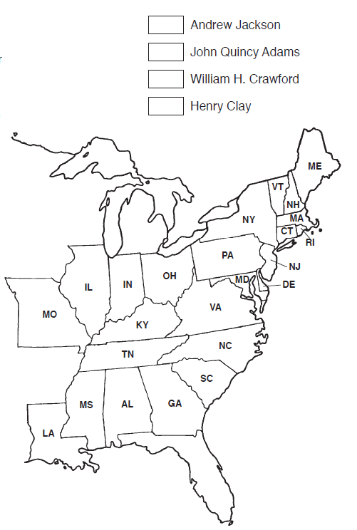
Election of 1828
- Candidates: President John Quincy Adams was running for reelection in 1828. His opponent was Andrew Jackson, who hoped to avenge a loss to Adams in the disputed Election of 1824. Adams’ supporters belonged to the National Republican Party. The challengers at first called themselves “Friends of Jackson,” but later used the name “Democrats.” They were the founders of today’s Democratic Party.

- The Campaign: Both Adams and Jackson were nominated by state legislatures and special conventions and mass meetings. This was the first time that no presidential candidate was chosen by a “caucus,” or meeting of members or leaders of a political party.
Both Adams and Jackson stayed in the background during the campaign of 1828. President Adams’ views on the issues were well known. He favored a national bank, a protective tariff, and the spending of federal monies for such internal improvements as roads and canals. He also wanted to develop new programs in science and education. The President’s strength was in the Northeastern states. His supporters included businessmen, bankers, and rich and well-educated people. Jackson took a different positions on the issues. He preferred a lower tariff, and thought internal improvements should be the responsibility of the states instead of the federal government. He wanted to give government jobs to those who, in his opinion, better represented the will of the people.
The Jacksonians ran a well-organized campaign. They put together national committees, state committees, and local “Hickory Clubs.” Newspapers were printed which convinced thousands of voters that Jackson was “the people’s candidate.” Jackson’s campaign leaders collected money, made lists of voters, thought up slogans, wrote political songs, handed out pamphlets, and organized parades, barbecues, dinners, and street rallies. Party workers distributed hickory brooms, hickory canes, and hickory sticks. They even planted hickory trees.
The National Republicans (Adam’s party) eventually realized that they too needed a strong political organization. They adopted the oak at their symbol, held some parades, and formed a number of committees. But it was too late to overcome their early lead of the Jacksonian Democrats.
In the months before the election, the mood of the campaign turned ugly. It became one of the bitterest political confrontations in American history. Both sides launched personal attacks on the opposing candidate. They often exaggerated the facts and told outright lies. The Jackson people said President Adams was like a king looking down on the common people. They said that their candidate’s common sense was more important than Adams’ “book learning.” When President Adams used his own money to buy a billiard table and some chessmen, he was accused of installing gambling equipment in the White House.
Meanwhile, the backers of Adams put out a pamphlet which said Andrew Jackson was unable to spell more than one word in every four. They drew up a long list of his “sins,” which they claimed including gambling, slave-trading, drunkenness, theft, lying, and even murder. He supposedly was in fourteen fights, duels, brawls, shoot-outs, and free-for-alls. But the worst remarks were directed at his wife Rachel. She had previously been married to a man named Lewis Robards, who had left her to get a divorce. Some time later, Rachel met Jackson and they were married. It was assumed that the divorce from Mr. Robards had been finalized, but it had not. When the divorce finally went through, the Jacksons remarried. Political opponents used this incident to question Mrs. Jackson’s morality. Rachel, who health was poor, suddenly died a month after the election. Jackson blamed her death on Adams and the National Republicans. At her funeral he exclaimed, “May God Almighty forgiver her murderers as I know she forgave them. I never can.”

- Election Results
Popular Votes Percent of Total Electoral Votes
Andrew Jackson 647,292 56 178
John Quincy Adams 507,730 44 83

- Map Exercise

State/Map Abbreviation | Jackson | Adams
Alabama (AL) | 5
Connecticut (CT) |  | 8
Delaware (DE) |  | 3
Georgia (GA) | 9
Illinois (IL) | 3
Indiana (IN) | 5
Kentucky (KY) | 14
Louisiana (LA) | 5
Maine (ME) | 1 | 8
Maryland (MD) | 5 | 6
Massachusetts (MA) |  | 15
Mississippi (MS) | 3
Missouri (MO) | 3
New Hampshire (NH) |  | 8
New Jersey (NJ) |  | 8
New York (NY) | 20 | 16
North Carolina (NC) | 15
Ohio (OH) | 16
Pennsylvania (PA) | 28
Rhode Island (RI) |  | 4
South Carolina (SC) | 11
Tennessee (TN) | 11
Vermont (VT) |  | 7
Virginia (VA) | 24
TOTALS: | 178 | 83

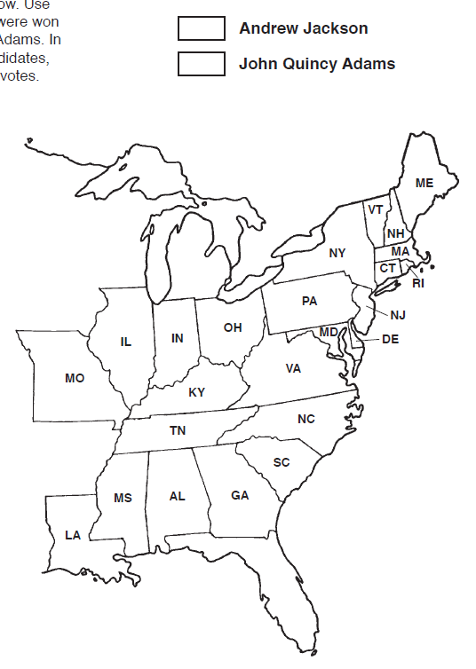

Questions on the Election of 1824

- All four candidates belonged to which political party?

- Which party had disappeared during the Era of Good Feeling?

- Did the four leading candidates share the same views on the issues?

- Who did President James Monroe hope would win the election?

- How many candidates were Cabinet officials at the time of the election?

- How many candidates were members of Congress?

- Different opinions on various issues tended to divide the country into how many sections?

- Did more than half of the voters in the Election of 1824 cast their ballots for Andrew Jackson?
- In order to win a presidential election, does a candidate need to win a majority of the popular vote or the electoral vote?

- What number of electoral votes was needed to win the Election of 1824?

- When no candidate receives a majority of the electoral votes, who chooses the President?

- Which man was accused of making a “corrupt bargain” with Henry Clay?

- How many candidates were involved in the special run-off election in the House of Representatives?

- Who was the leading candidate from the west?

- Who won the Election of 1824?

Questions on the Election of 1828

- To which political party did President John Quincy Adams belong?

- Which party was eventually organized by the “Friends of Jackson?”

- Were Adams and Jackson selected as presidential candidates at party caucuses?

- Did the two candidates travel around the country giving speeches on the issues?

- Which man favored a national bank, a protective tariff, and the spending of money for internal improvements?

- Who thought of himself as a true representation of the people?

- Did the Jackson people or Adams supporters show the most skill in putting together an effective campaign?

- Did Jackson win 56% of the popular votes or 56% of the electoral votes?

- Which candidate carried the south and the west?

- In what section of the United States was Adams the strongest?
- In how many of the 24 states did Jackson win the most electoral votes?

- Which state had the most electoral votes?

- What is the smallest number of electoral votes a state can have?

- Who won the Election of 1828?

- Did the victorious candidate win the election by a wide margin or a narrow margin?

