GETTYSBURG AND VICKSBURG

As you read these pages, put yourself in the position of being Abraham Lincoln, Jefferson Davis, Ulysses S. Grant, and Robert E. Lee. These people had to make important decisions which affected the outcome of the Civil War. Decide what you would have done, given the circumstances described in the background information preceding the questions.

Background for Questions 1 and 2
Two years have passed since the beginning of the Civil War. The Union has been successful in the West, capturing Fort Henry and Fort Donelson. They now threaten Vicksburg, the last Confederate stronghold on the Mississippi River.
Meanwhile, in the East, the Confederates have outmaneuvered and outfought Union troops at Bull Run twice, the Seven Days’ Battles, Fredericksburg, and Chancellorsville. The only significant Union victory has been at Antietam, where a Confederate invasion of the North was turned back.
With Union victories in the West being offset by successes in the East, neither side is close to winning the war. It appears that many more battles will have to be fought, and many more lives sacrificed, before a winner is determined.

Question 1: If you were President Lincoln, which would you do at this time? (a) end the bloodshed by signing a peace treaty with the South, allowing the Confederate States of America to exist as a separate country (b) continue the war because the Union must be preserved

Question 2: If you were Jefferson Davis, President of the Confederate States of America, what would you do? (a) decide it is impossible for the South to win the war, and agree to rejoin the Union (b) continue the war, and hope that the North tires of fighting allows the South to remain a separate country

Background for Questions 3 and 4
It is now April 1863. Union forces under General Ulysses S. Grant are trying to capture Vicksburg on the Mississippi River. If Vicksburg falls, the North will gain control of the Mississippi and cut the railroad link between the eastern and western halves of the Confederacy.
In the East, Confederate troops under General Robert E. Lee have just won a key victory at Chancellorsville. The Confederates are most confident than ever, even though the Northern army still has a sizeable advantage in manpower and war materials. General Lee has shown that he is a far better commander than any of the many Northern generals who have taken turns at failure – Irvin McDowell, George B. McClellan, John Pope, Ambrose E. Burnside, and Joseph Hooker.

Question 3: If you were General Lee, what would you do next? (a) follow up the victory at Chancellorsville with an invasion of the North, thereby threatening Washington and other Northern cities (b) keep your army in Virginia to protect Richmond (c) send art of your army into the West to help defend Vicksburg

Question 4: If you were President Lincoln, what action would you take? (a) allow General Hooker to continue as commander in the East, despite his defeat at Chancellorsville, become too many changes have already been made (b) replace Hooker with Grant, who has proven his ability during campaigns in the West; put someone else in Grant’s place at Vicksburg (c) let Grant finish his campaign against Vicksburg; put another man at the head of the Union Army in the East

Background for Question 5
The Battle of Gettysburg was fought in southern Pennsylvania on July 1-3, 1863. It proved to be the decisive battle of the war. General Lee had marched north from Virginia with 75,000 troops. He was met by General George Meade, the new Union commander, and an army of 90,000 men.

Question 5: It is now the third day of the battle. Neither side has gained a significant advantage during the first two days. If you were General Lee, which would you decide to do? (a) send Pickett’s troops against the center of the Union line in an attempt to divide Meade’s army in half (b) attack the Union left near “Big Round Top” and “Little Round Top” (c) hold your present position and wait for the Union to attack (d) decide that the Union position is too strong, and retreat from the battlefield.

Background for Question 6
Vicksburg, located on the eastern bank of the Mississippi River, is situated on a steep bluff 235 feet above the river. The area to the north and northeast is made up of forest-covered cliffs, lakes, streams, swamps, and bayous. The land to the south and east offers easier travel, but a Union approach from this direction would be opposed by additional Confederate troops in the area.
Union soldiers number 41,000 and are commandeered by General Ulysses S. Grant. The Confederates have 35.000 at Vicksburg under General John C. Pemberton, and another 15,000 scattered in the area between Vicksburg, Jackson, and Grand Gulf.

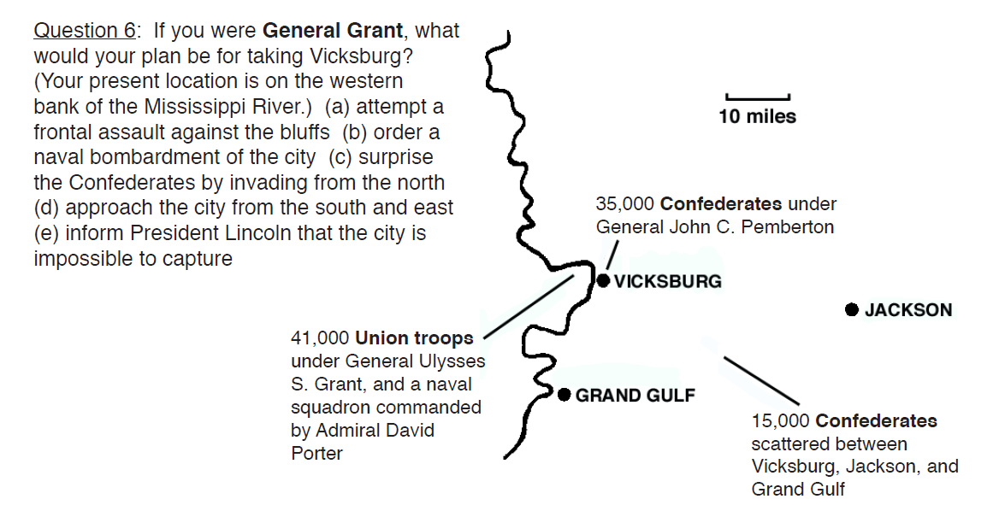
Background for Question 7
After seven battles, and seven victories, Union troops have forced the Confederate the Confederates back into the city of Vicksburg. Union soldiers now outnumber the Confederates, but the Southerners occupy a strong defensive position.

Question 7: If you were General Grant, what would your strategy be? (a) attack the city, figuring that your advantage in numbers will overcome the enemy’s superior defensive position (b) prepare for a long siege, which will cut off all supplies to the city and lead to an eventual surrender (c) recognize a hopeless situation and quickly withdraw your army from the area, sending it immediately into another state to surprise the Confederates there.

Background for Question 8
It is July 5, 1863. In the last two days, Union forces have gained two major victories. In the West, they have divided the Confederacy by capturing Vicksburg and taking control of the Mississippi River. In the East, they have stopped the Confederate invasion of the North at Gettysburg.

Question 8: What would you do if you were President Jefferson Davis? (a) surrender now, realizing that it is just a matter of time before the stronger Northern army defeats the Southern army (b) continue the war until all hope for victory disappears.

