The Antebellum South

Early Emancipation in the North
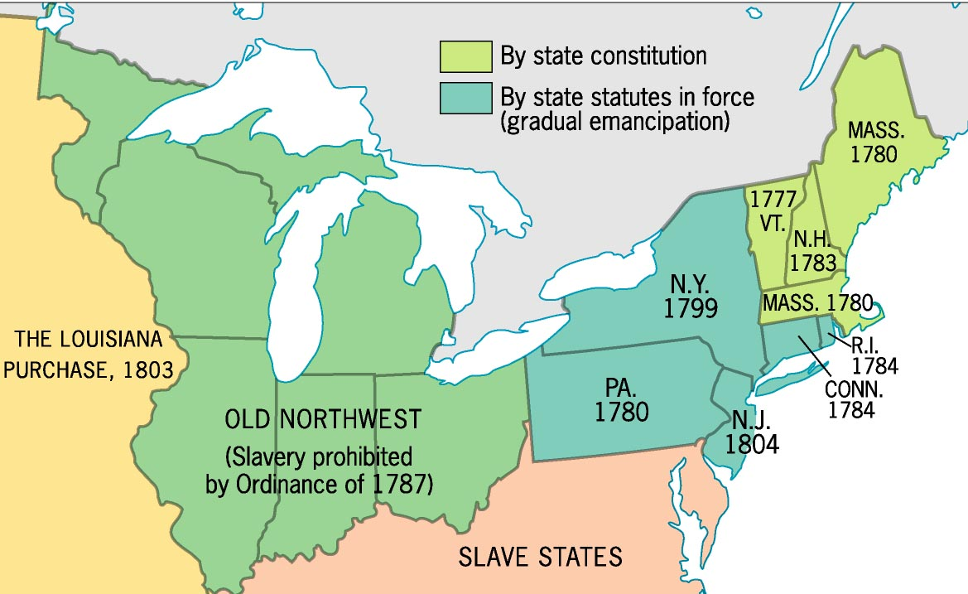

The Missouri Compromise
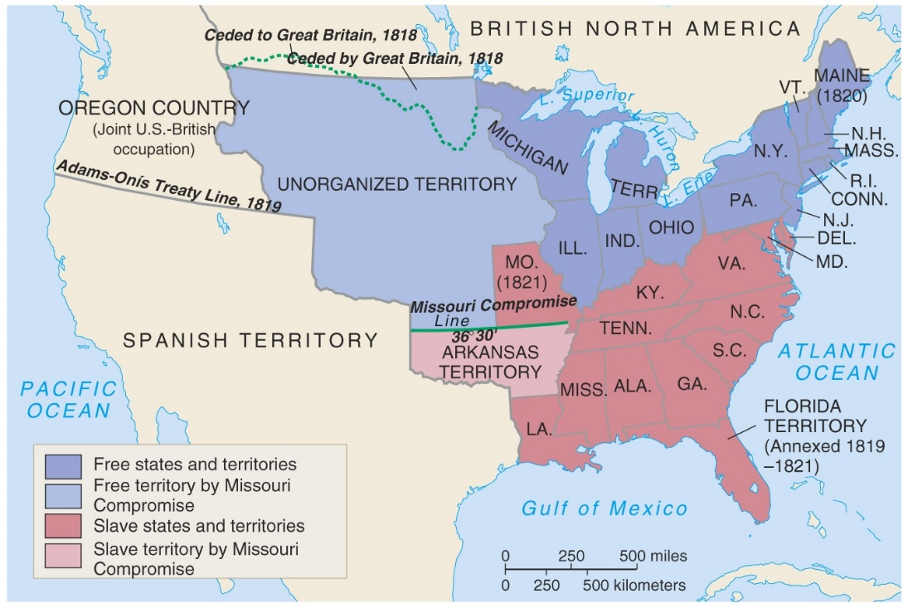

Antebellum Southern Society

Characteristics of the Antebellum South
- Primarily ______________________________________
- Economic power shifted from the “________________ South” to the “______________________ South”
  - Ex. _________________________ to ____________________________
- “____________________________ is King!”
  - 1860 5 mil bales a year (_____% of total US exports)
- Very slow development of __________________________________
- Rudimentary ______________________________ system
- Inadequate _________________________________ system
Southern Society (1850)

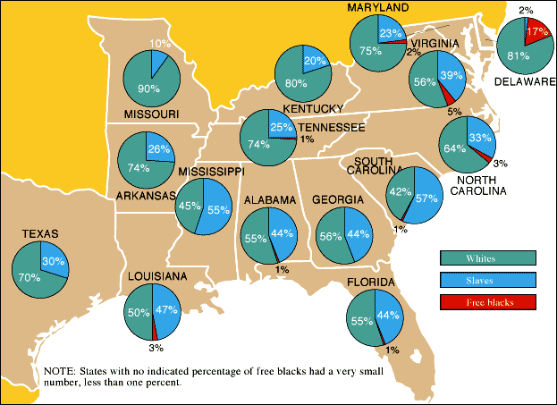
Southern Population

Which two states had a larger percentage of slaves than whites?

Antebellum Southern Economy

__________________________________ Textile Company
*** Founded in ______________, it was the South’s first attempt at ______________________________ in Richmond, VA. ***
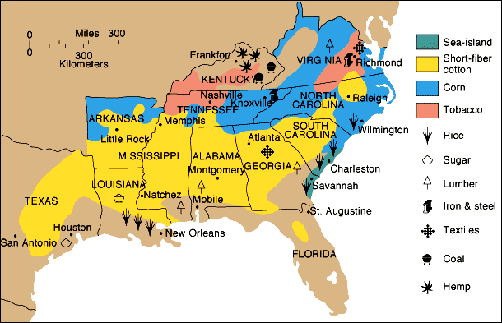
Southern Agriculture

What was the main crop of the southern economy?

Value of cotton exports as a percentage of all US exports
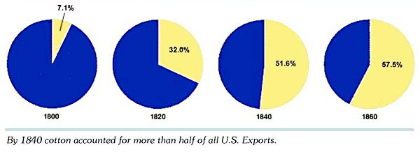

The South’s “Peculiar Institution”

Slave Accoutrements

- Slave _________________________
- Slave master _______________________
- Slave leg ____________________
- Slave ______________, SC
- Slave ______________________

Antebellum Southern Plantation Life

Slave-Owning Population in 1850
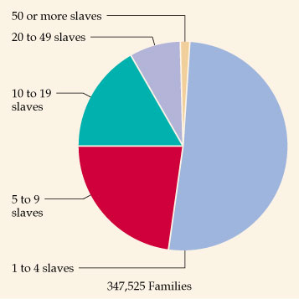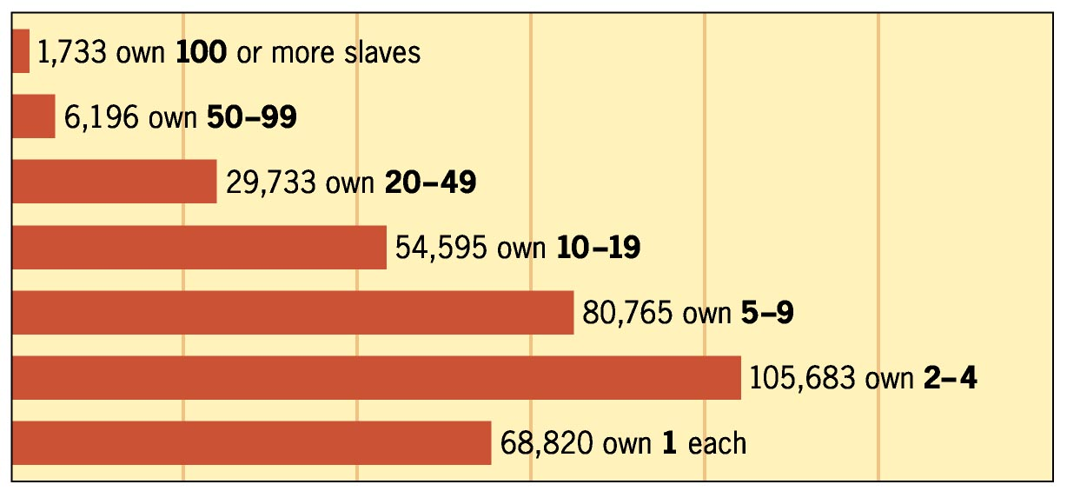
Tara – Plantation Reality or Hollywood’s Version?

Was the depiction of life on Tara realistic in terms of white-black relationships in the Antebellum South? (Think about the interactions between Scarlet and Mammie)

U.S. Laws Regarding Slavery
1. U.S. Constitution
2. 1793 Fugitive Slave Act
3. 1850 stronger Fugitive Slave Act

Southern Slavery An Aberration?
- 1780s: 1st ____________________________ society created in Phila.
- By 1804: slavery eliminated from last ____________________________ state.
- 1807: the legal _________________________________ of the slave trade, enforced by the Royal Navy.
- 1820s: newly indep. Republics of _______________________ & So. America declared their slaves free.
- 1833: slavery abolished throughout the __________________________ Empire.
- 1844: slavery abolished in the _______________________. colonies.
- 1861: the ______________ of Russia were emancipated.

Slavery was Less Efficient in the U.S. than Elsewhere
- High ______________________ of keeping slaves from _____________________________
- Goal raise the “________________________________”
  - Slave ________________________
  - Southern Black __________________________
  - Cut off a __________________ or a ______________________

Slave Resistance & Uprisings

Slave Resistance
- ___________________________ pattern of behavior used as a ________________________ in front of whites [the innocent, _______________________ black man caricature – bulging eyes, thick lips, big smile, etc.]
- ______________________________ to work hard
- Isolated acts of ___________________________________
- Escape via the _________________________________________________________

Quilt Patterns as Secret Messages
- The _______________________________________________ pattern alerted escapees to gather up ______________________ and prepare to flee; the _______________________________________ design warned escapees not to follow a ____________________________ route.

Slave Rebellions throughout the world

The Culture of Slavery
- Black ___________________________________ [Baptists or ________________________________]:
  - More ________________________ worship services
  - Negro ___________________________
- “__________________” or ______________________ languages
- Nuclear family with extended ______________ links, where possible
- Importance of _________________________ in their lives

