THE ELECTION OF 1860
- Background Events
Bloody fighting in Kansas, the controversial Dred Scott decision, and John Brown’s raid on Harpers Ferry drove the free and slave states farther apart. The Republican Party, which was formed in 1854 to oppose the extension of slavery into the territories, had gained large numbers of followers in the North. Southern politicians threatened to secede from the Union if a Republican was elected President in 1860.

- Candidates
Delegates at the Democratic convention were unable to agree upon a presidential candidate. Northerners and Southerners in the party held different positions on the slavery issue. When delegates from eight Southern states walked out of the convention, the meeting was adjourned. Two months later, the Northerner Democrats reassembled and nominated Stephan A. Douglas of Illinois for President. The Southern Democrats then picked John C. Breckinridge of Kentucky. Meanwhile, Abraham Lincoln of Illinois won the Republican nomination. A fourth candidate, John Bell of Tennessee, was chosen by the Constitutional Union Party.

Each of the candidates had a different point of view toward slavery:

Stephan A. Douglas (Northern Democrats) supported the idea of popular sovereignty. He wanted the people of a territory to decide for themselves if they wanted slavery or not.

John C. Breckinridge (Southern Democrats) believed slavery should be permitted in any U.S. territory, and that the people there could not vote to close the area to slave-owners.

Abraham Lincoln (Republican Party) opposed the extension of slavery into the territories. But he did not call for the abolition of slavery in the Southern states which already allowed it.

John Bell (Constitutional Union Party) purposely ignored the slavery issue. He stressed that laws established by the Constitution should be obeyed, and that the Union must be held together despite sectional differences.

- The Campaign
The contest for President became in effect two separate campaigns: Lincoln v. Douglas in the North, and Bell v. Breckinridge in the South. Lincoln was not even on the ballot in the Southern states. Bell, Breckinridge, and Lincoln, keeping with tradition, did not actively campaign for office. They left the electioneering to party supporters. But the energetic Douglas, once described as a “steam engine in britches,” decided to hit the campaign trail. Using the excuse that he was going to New York to visit his mother, he gave speeches throughout the Northeast before finally arriving at her home. During the four weeks that he took to reach New York, the Republicans blasted him for campaigning instead of going directly to his mother’s house. The Republicans sarcastically issued the following message under the heading “A Boy Lost!”:

“Left Washington, D.C., some time in July, to go home to his mother. He has not yet reached his mother, who is very anxious about him. He has been seen in Philadelphia, New York City, Hartford, and at a clambake in Rhode Island. He has been heard from at Boston, Portland, Augusta, and Bangor, Maine. He is about five feet nothing in height and about the same diameter. He has a red face, short legs, and a large belly. Answers to the name of Little Giant, talks a great deal, very loud, always about himself. He has an idea that he is a candidate for president”

A Republican newspaper in Lincoln’s home state of Illinois added:

“Douglas is going about peddling his opinions as a tin man peddles his wares. The only excuse for his is that he is a small man, he had a right to be engaged in small business, and small businesses it is for a candidate for the presidency to be strolling around the country begging for votes.”

While Stephen A. Douglas became the first candidate in American history to campaign for the presidency, Abraham Lincoln stayed in Springfield, Illinois. He was visited by friends, politicians, office seekers, reporters, photographers, and painters. During these months, his political opponents had much to say about him, including unkindly remarks about his looks. A Southern newspaper commented:

“Lincoln is the leanest, lankest, most ungainly mass of legs and arms and hatchet face ever strung on a single frame. He has most certainly abused the privilege of being ugly.”

In the end, two factors determined the outcome of the election. First, Lincoln’s Republican Party attracted large number of votes in the North and West by adopting a platform which included: (1) opposition to the extension of slavery into the territories (2) a Homestead Act giving free land to Western farmers (3) the building of a transcontinental railroad that would boost trade between the North and West, and (4) a tariff which would protect Northern manufacturers from cheaper foreign goods. The second factor that turned the election in Lincoln’s favor was a split in the Democratic Party. The Northern Democrats’ choice of Stephen A. Douglas, and the Southern Democrats’ nomination of John C. Breckinridge, hopelessly divided the party’s votes in the election.

- Election Results
Popular Votes Percent of Total Electoral Votes
Abraham Lincoln (Republican Party) 1,867,198 39.8 180
Stephen A. Douglas (Northern Democrat) 1,379,434 29.4 12
John C. Breckinridge (Southern Democrat) 854,248 18.2 72
John Bell (Constitutional Union) 591,658 12.6 39

Despite having less than 40% of the popular votes, Lincoln easily won a majority of the electoral votes. The South now feared the Republicans would not only oppose slavery in the territories, but would work to abolish it in the Southern states which depended upon slave labor. South Carolina reacted to Lincoln’s victory by declaring that it was seceding from the Union. Alabama, Florida, Georgia, Louisiana, Mississippi, and Texas also decided to secede. Delegates from these seven states formed the Confederate States of America. Jefferson Davis was chosen President. All of these events took place during the four months between Election Day and the day when Lincoln was inaugurated as the 16th President.

Meanwhile, President James Buchanan, who was serving out his term, took no action to stop the secession movement. He allowed the Southerners to take over federal forts and arsenals, where large supplies of weapons were stored. Buchanan believed it was more important to preserve the peace until Abraham Lincoln became the new President.

- Map Exercise
The map below shows 33 states which belonged to the Union at the time of the Election of 1860. The chart gives state-by-state electoral vote results. Use four different colors, or four different markings, to show these results on the map. Put the same colors or markings in the key.

Note: In New Jersey, where the electoral votes were divided between two candidates, color or mark the state for Lincoln since he received the most votes.

State/Map Abbreviation | Lincoln | Douglas | Bell | Breckinridge
Alabama (AL) |  |  |  | 9
Arkansas (AR) |  |  |  | 4
California (CA) | 4
Connecticut (CT) | 6
Delaware (DE) |  |  |  | 3
Florida (FL) |  |  |  | 3
Georgia (GA) |  |  |  | 10
Illinois (IL) | 11
Indiana (IN) | 13
Iowa (IA) | 4
Kentucky (KY) |  |  | 12
Louisiana (LA) |  |  |  | 6
Maine (ME) | 8
Maryland (MD) |  |  |  | 8
Massachusetts (MA) | 13
Michigan (MI) | 6
Minnesota (MN) | 4
Mississippi (MS) |  |  |  | 7
Missouri (MO) |  | 9
New Hampshire (NH) | 5
New Jersey (NJ) | 4 | 3
New York (NY) | 35
North Carolina (NC) |  |  |  | 10
Ohio (OH) | 23
Pennsylvania (PA) | 3
Rhode Island (RI) | 27
South Carolina (SC) | 4 |  |  | 8
Tennessee (TN) |  |  | 12
Texas (TX) |  |  |  | 4
Vermont (VT) | 5
Virginia (VA) |  |  | 15
Wisconsin (WI) | 5
180 12 39 72
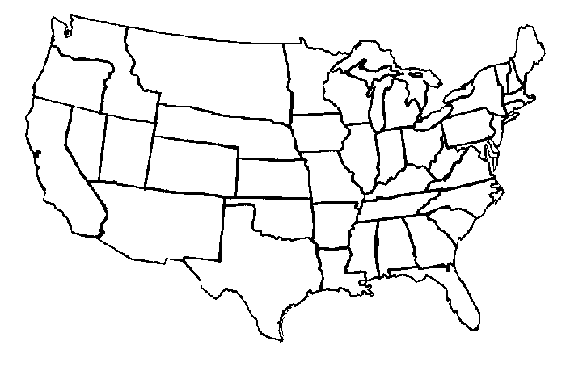
Abraham Lincoln (Republican)

Stephen A. Douglas (Northern Democrat)

John Bell (Constitutional Union)

John C. Breckinridge (Southern Democrats)
- Questions on the Election of 1860
Use the information on the preceding pages, and your knowledge of how Presidents are chosen, to answer the following questions. Fill in each space with the candidates being described – Lincoln, Douglas, Breckinridge, or Bell.

- _______________________________ Believed the existence of slavery in the territories should be determined by popular sovereignty.
- _______________________________ Was the Republican Party candidate.
- _______________________________ Democrat whose political strength was in the South.
- _______________________________ Said that slavery should be permitted in any U.S. territory.
- _______________________________ First candidate in American history to actively campaign for President.
- _______________________________ Won the electoral votes of the Northern states by expressing his opposition to slavery in the territories.
- _______________________________ Ignored the slavery question although, saying that the most important issue was preserving the Union.
- _______________________________ His only electoral votes came from three Border States between the North and South.
- _______________________________ His party’s platform called for a protective tariff, a Homestead Act, and the building of a transcontinental railroad.
- _______________________________ Seven Southern states seceded and formed the Confederate States of American after he won the Election of 1860.

Fill in the missing words, terms, names and numbers:

Abraham Lincoln won the Election of (11) ________________________ by capturing 180 (12) _____________________________. A total of 303 electoral votes were cast for the four candidates. Since a majority (over half) of the total number of electoral votes is needed to become President, at least (13) ______________________ (how many?) votes were needed to win the presidency in 1860.
(14) _____________________________ received the most (15) ________________________ votes, followed by (16) _________________________________ of the Northern branch of the Democratic Party. Even though Douglas got a large number of popular votes, he finished a distant fourth with only (17) ___________________________ electoral votes. This happened because he was consistently edged out in the popular voting in the Northern and Western states by (18) ____________________________ of the victorious (19) _____________________________ Party. Usually, the candidate who wins the most popular votes in a state gets all of that state’s (20) ___________________________________. The only exception to this rule in the Election of 1860 was in the state of (21) ______________________________, where Lincoln and Douglas both received votes.
The state-by-state election results clearly showed the sectional differences which existed in the country. Abraham Lincoln dominated the voting in the (22) _______________________________ and Western states, while (23) __________________________________ carried the Southern states.
The state with the most electoral votes was (24) __________________________________. According to the United States Constitution, no state has fewer than (25) ________________________ electoral votes in a presidential election.

