Name: Date:
US History Ms. Byrne

War of 1812

Causes of the War of 1812
- In __________, Britain and France went to war again.
- Both countries ______________ U.S. ships sailing towards the __________ of their enemy.
- Britain continued its’ ________________________ of U.S. sailors
  - Between _________ and __________ over _________________ Americans were impressed by the British
  - British ships frequently stopped American ships, _______________________ their cargo, and impressed (____________________) crew members, claiming they were _________________ from Britain’s Royal ______________

Embargo Act (1807)
- The Embargo Act banned __________ ships from trading with any country
- All ______________ and _______________ were banned!
- This ___________ the U.S. economy

Non-Intercourse Act (1809)
- Trade with _______ _______________ was allowed except _________________ or _________________

War Hawks
- Members of ________________, led by ________________ ____________ of Kentucky, who wanted to declare war on Great Britain
- Rationale for War
  - Nationalism
    - Pride or __________________ to one’s country
    - Many American felt that __________ __________________ still treated the United States like a British ________________
  - Revenge
    - War Hawks wanted to revenge on British for ________________ American ships
  - Territorial Expansions
    - ______________ _________ wanted an excuse to conquer __________________ from Great Britain and __________________ from Spain
  - Native American Attacks
    - War Hawks felt that Great Britain was _________________ Native Americans on the frontier and ______________________ them to attack Americans

The Prophet and Tecumseh
- _____________________________, also known as “The Prophet”, believed that in order to survive, Native American had to give up ___________ __________ of life.
- Tecumseh ___________________ many tribes behind the message of the Prophet, who was his ___________ ________________
- In ____________, the Prophet built a ______________ for his followers in _________________, Indiana

Showdown at Tippecanoe
- In ____________, fearful of the growing strength of the Prophet and Tecumseh, Governor ___________________ _____________ ____________________ led 1000 troops against them in the Battle of ______________________
- The battle was viewed by Americans as a __________ _________________, even though it was unclear which side actually won

American Problems
- The US was unprepared militarily:
  - Had a ____ _________ navy vs. Britain’s ___________ ships.
  - Americans disliked a ____________ - preferred to enlist in the ___________________ state militias.
- Financially unprepared:
  - Flood of paper _________________ _______________ declined.
- Regional disagreements.

Overview of the War of 1812 Where is this war occurring? (Name a couple locations)
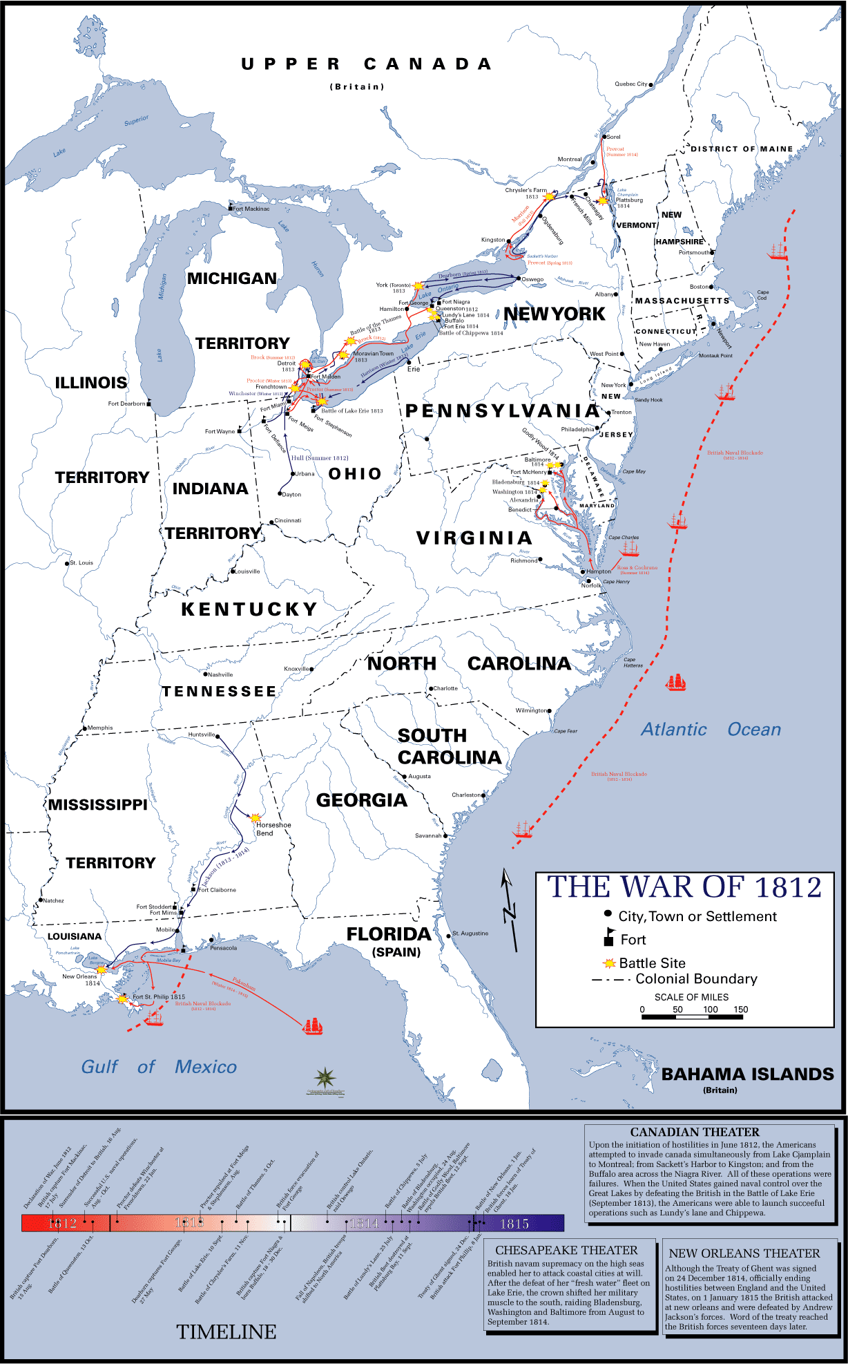
3 U. S. Invasions of 1812
Where and when are the three invasions?

Campaigns of 1813

Battle of Fort McHenry,1814
What famous poem/song is written during this battle?

Who wrote the lyrics?

What is the song about?

Attack on Ft. Oswego, 1814
Results?
- British gained ________________ barrels of ____________________
- British captured ________________________
- Missed the _____________________ to gain _____________________ as they were on the way to Oswego at the time of attack

Hartford Convention December, 1814 – January, 1815
**** What happened?****

Treaty of Ghent December 24, 1814
- Peace was established on ________ _______ ________________
  - Things go back to the way they were ___________ ______ ___________

The Battle of New Orleans, 1815
- Occurred after the war ____________________ ended
- January 1815, British landed with 7500 troops in _________ _______________
- _____________ __________________ used cotton bales as _______________ and then easily picked off the British in an _________ ______________
- Made Andrew Jackson a _______________ _________

Jackson’s Florida Campaigns
**** Why was Florida important?****

